Genesis Grant

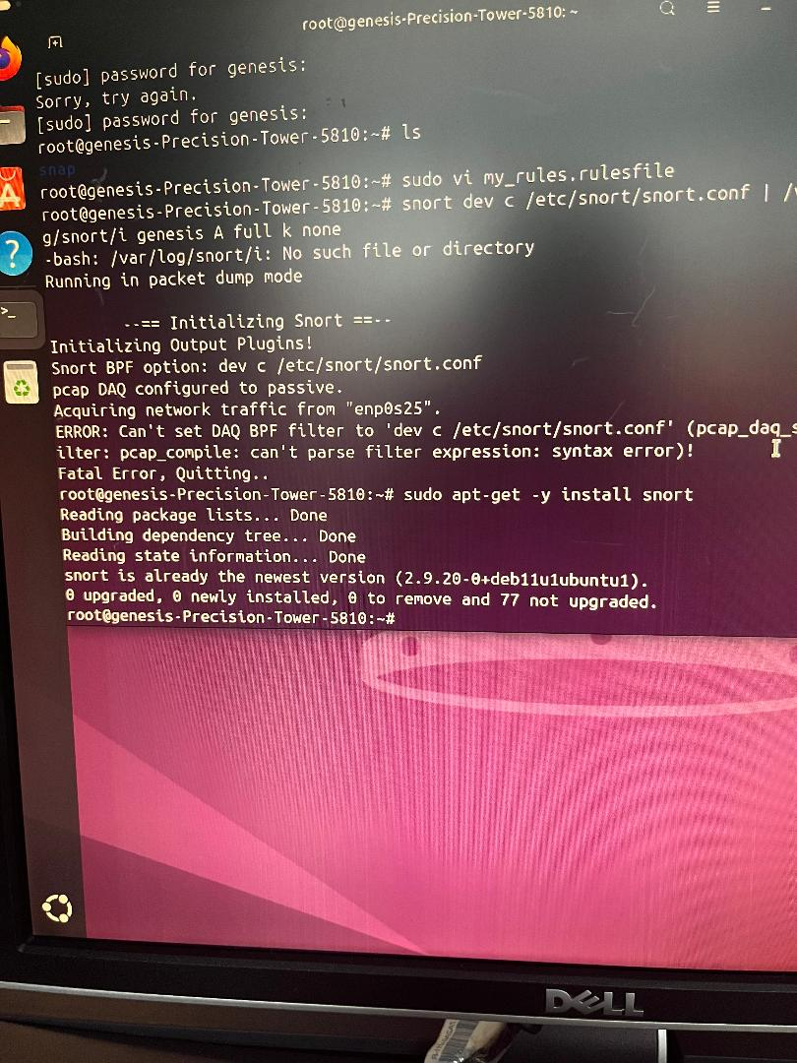SNORT Assignment

